United States | Reprising the reprisals

Letitia James is the latest target of Donald Trump’s revenge agenda

Federal prosecutors have indicted New York’s attorney-general
SaveShare
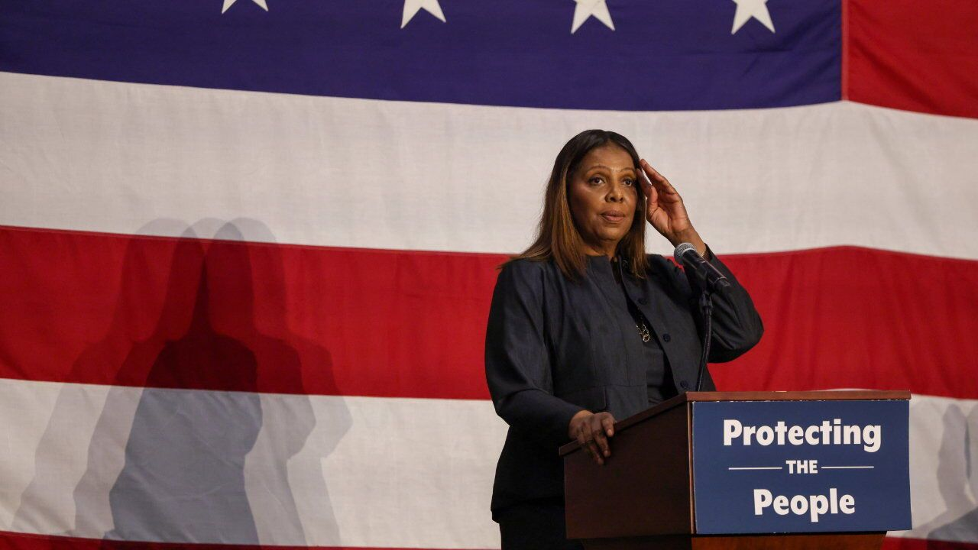
The Economist, Oct 10th 2025
SOME YEARS ago a noted defence lawyer made a provocative claim: all Americans could be considered criminals. Federal laws are so vague, wrote Harvey Silverglate, that everyone unwittingly runs afoul of them at some point. Armed with the power of the state, an overzealous prosecutor could build a case against practically anyone, making good on that Stalin-era line: “Show me the man and I’ll show you the crime.”
Or show me the woman. On October 9th a grand jury indicted Letitia James, New York’s attorney-general and a longtime foe of Donald Trump, on two felony counts related to a mortgage application. The indictment follows perjury charges filed against James Comey, a former FBI director who also antagonised the president. Mr Trump had demanded that both be investigated and, impatient with what he considered prosecutors’ dilly-dallying, he ordered them to hurry it up. Together the indictments—and there will probably be others—are turning the Department of Justice (DoJ) into a tool for Mr Trump’s score-settling.
The president has targeted Ms James after she sued him successfully for fraud at his real-estate business. Last year a judge ordered him to pay a fine of nearly half a billion dollars. The penalty was erased on appeal, but not the fraud finding. Mr Trump said the whole thing was a “fraud on me” and called Ms James a “monster”.
Now prosecutors allege that she lied on a mortgage application for a property she bought in Virginia. According to the DoJ, Ms James attested that it would be her second home when in fact she rented it out. This alleged deception got her a better interest rate, the government charges. Such cases require prosecutors to prove both the defendant’s intent and that any misrepresentations were material, meaning the bank would not have offered the loan if it had known the truth. That is a high bar.
Ms James called the charges “baseless”. Reportedly some career lawyers at the DoJ thought so too. The acting US attorney overseeing the case—himself a career prosecutor—advised dropping it and then resigned rather than push ahead. According to lawyers for Ms James, investigations of her appear to have involved two MAGA acolytes in the Trump administration: Ed Martin, who previously defended January 6th rioters while in private practice, and Bill Pulte, the director of the Federal Housing Finance Agency. In August Mr Martin appeared for a photoshoot outside Ms James’s house in New York, dressed in a trenchcoat (looking disconcertingly like Lieutenant Columbo). At the DoJ he leads a taskforce to redress past weaponisation of the law.
The rationale for Mr Trump’s revenge tour is that Democrats started it. The DoJ under Joe Biden indicted him twice. Democratic state prosecutors indicted him twice more. Ms James brought her civil suit. Some of the criminal cases against Mr Trump relied on speculative legal theories, including the only one that went to trial (and produced a conviction). That particular case was also over small-bore stuff: paying hush-money to a porn star. This bolstered Mr Trump’s claim that prosecutors were playing politics. In 2018 Ms James even campaigned on the promise to be a “real pain in [his] ass”, saying “he’s going to know my name personally.”
The president’s revenge-seeking is as explicit. Judging by the charges against Ms James and Mr Comey—who was indicted for lying to Congress—it may also be more tenuous. This politicisation of the law will also change how the DoJ operates. More prosecutors will be forced out or will quit over ethical objections, adding to what has already been an exodus. Ideologues or less experienced staff will fill the ranks.
The other effect may be a cycle of reprisal lasting for years. It stands to reason that the next Democratic president will pardon enemies of Mr Trump who get convicted and may also target the president’s allies. A ceasefire will only come when outrage builds and both parties “feel the sting”, says Saikrishna Prakash of the University of Virginia. “It may have to get worse before it gets better.”
In the meantime judges and jurors can provide a check against a rogue DoJ. Already they have done so in Chicago, Los Angeles and Washington, DC. When prosecutors in those cities brought flimsy cases against protesters and people arrested in Mr Trump’s crime crackdown, grand juries refused to indict. That is rare and embarrassing for prosecutors, since their burden of proof—probable cause—is much lower at that early stage.
To win a conviction against Ms James, Mr Comey or indeed any defendant at trial, the DoJ needs a jury to deliver a guilty verdict unanimously, beyond a reasonable doubt. The misgivings of some prosecutors suggest that this may be difficult in these two particular cases. If they fail, Mr Trump’s revenge agenda will end up looking like a series of nuisance lawsuits, a way to hassle opponents. It is a strategy he knows well from his experience as a serial plaintiff.

